ITA06 - Machine Learning

EXP NO:1
Implement and demonstrate the FIND-S algorithm for finding the most specific hypothesis based on a given set of training data samples.

AIM
To implement the Find-S algorithm to find the most specific hypothesis from the given training data.
ALGORITHM
Initialize the hypothesis h with the most specific values (0).
- Read the training examples.
- Consider only positive examples (Yes).
- Compare each attribute with the hypothesis.
- If values are different, replace with ?.
- Repeat for all training examples.
- Display the final hypothesis.

PROGRAM CODE:
# Find-S Algorithm Implementation

import pandas as pd

# Training dataset
data = {
'Sky': ['Sunny', 'Sunny', 'Rainy', 'Sunny'],
'Temp': ['Warm', 'Warm', 'Cold', 'Warm'],
'Humidity': ['Normal', 'High', 'High', 'High'],
'Wind': ['Strong', 'Strong', 'Strong', 'Strong'],
'EnjoySport': ['Yes', 'Yes', 'No', 'Yes']
}

df = pd.DataFrame(data)

print("Training Data:")
print(df)

# Separate attributes and target
attributes = df.iloc[:, :-1].values
target = df.iloc[:, -1].values

# Initialize hypothesis
hypothesis = attributes[0].copy()

print("\nInitial Hypothesis:", hypothesis)

# Apply Find-S algorithm
for i in range(len(attributes)):
if target[i] == "Yes":
for j in range(len(hypothesis)):
if hypothesis[j] != attributes[i][j]:
hypothesis[j] = '?'

print("\nFinal Most Specific Hypothesis:")
print(hypothesis)
OUTPUT:
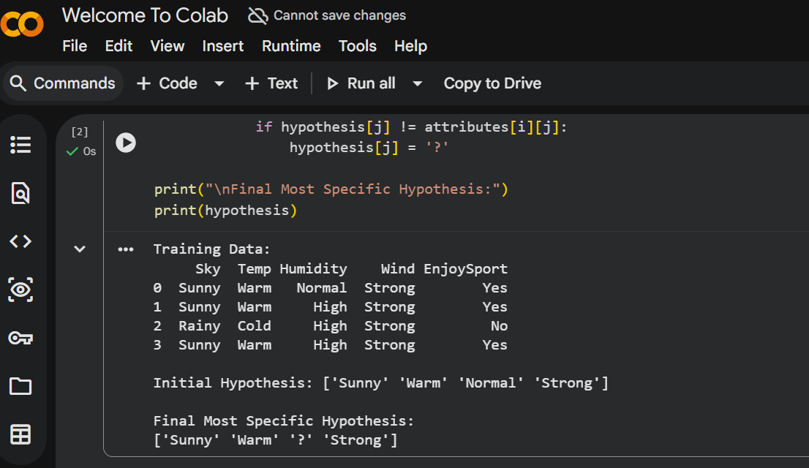
RESULT
Thus, the Find-S algorithm was successfully implemented using Python, and the most specific hypothesis consistent with the given training data was obtained.

EXP NO:2
For a given set of training data examples stored in a .CSV file, implement and demonstrate the Candidate-Elimination algorithm in python to output a description of the set of all hypotheses consistent with the training examples

AIM
To implement the Find-S algorithm to find the most specific hypothesis from the given training data using Python.

ALGORITHM
- Initialize the hypothesis h with the most specific values (0).
- Read the training dataset.
- Select the first positive example.
- Compare the hypothesis with each positive training example.
- If an attribute value differs, replace it with ?.
- Ignore negative examples.
- Repeat the process until all examples are processed.
- Display the final hypothesis.

PROGRAM
# Find-S Algorithm

data = [
['Sunny','Warm','Normal','Strong','Yes'],
['Sunny','Warm','High','Strong','Yes'],
['Rainy','Cold','High','Strong','No'],
['Sunny','Warm','High','Strong','Yes']
]

# number of attributes
n = len(data[0]) - 1

# initialize hypothesis
hypothesis = ['0'] * n

for sample in data:
if sample[-1] == "Yes":
for i in range(n):
if hypothesis[i] == '0':
hypothesis[i] = sample[i]
elif hypothesis[i] != sample[i]:
hypothesis[i] = '?'

print("Final Hypothesis:", hypothesis)

OUTPUT:
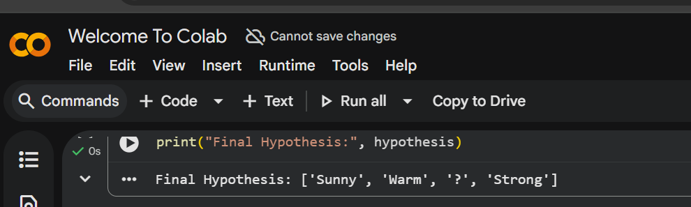

RESULT
Thus, the Find-S algorithm was successfully implemented and the most specific hypothesis consistent with the given training examples was obtained.

EXP NO:3
Demonstrate the working of the decision tree based ID3 algorithm. Use an appropriate data set for building the decision tree and apply this knowledge to classify a new sample.

AIM
To implement a Decision Tree using the ID3 algorithm and classify a new sample.
ALGORITHM
- Calculate entropy of the dataset.
- Compute information gain for each attribute.
- Choose the attribute with highest information gain as root.
- Split dataset based on that attribute.
- Repeat until all samples are classified.
- Use the tree to classify new data.
CODE
from sklearn.tree import DecisionTreeClassifier
from sklearn.datasets import load_iris
from sklearn.model_selection import train_test_split

data = load_iris()

X_train,X_test,y_train,y_test = train_test_split(data.data,data.target,test_size=0.3)

model = DecisionTreeClassifier()
model.fit(X_train,y_train)

print("Accuracy:",model.score(X_test,y_test))
OUTPUT:
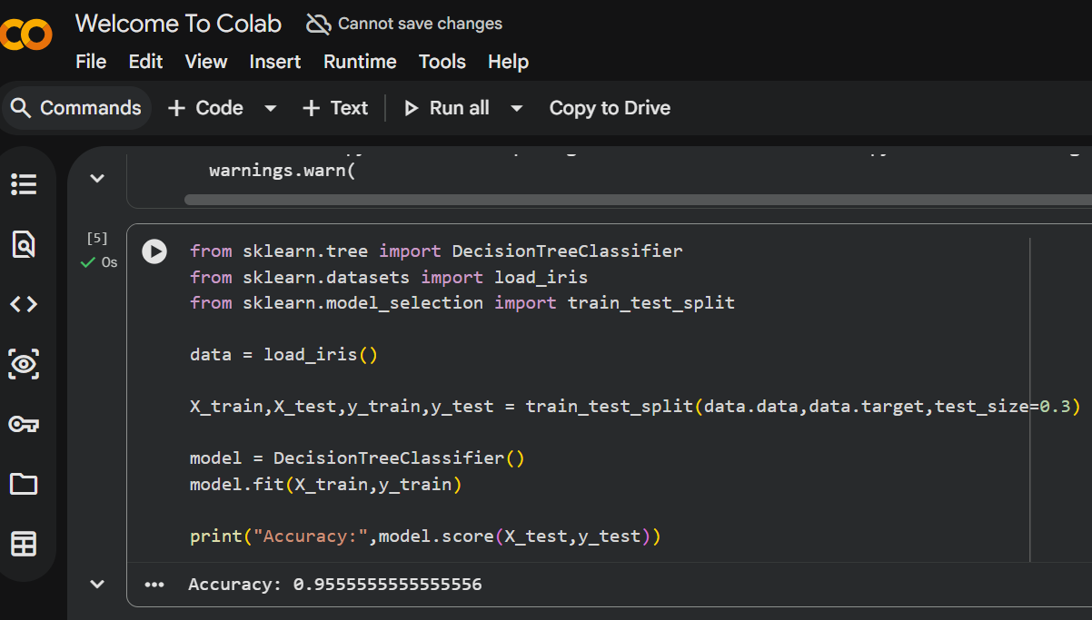
RESULT
Thus the Decision Tree using ID3 algorithm was successfully implemented and classification was performed.

EXP NO:4
Build an Artificial Neural Network by implementing the Backpropagation algorithm and test the same using appropriate data sets.
AIM
To build an Artificial Neural Network using the Backpropagation algorithm.
ALGORITHM
- Initialize weights randomly.
- Provide input data.
- Perform forward propagation.
- Compute error between predicted and actual output.
- Update weights using backpropagation.
- Repeat until minimum error is obtained.
CODE
from sklearn.neural_network import MLPClassifier
from sklearn.datasets import load_iris
from sklearn.model_selection import train_test_split

data = load_iris()

X_train,X_test,y_train,y_test = train_test_split(data.data,data.target,test_size=0.3)

model = MLPClassifier(hidden_layer_sizes=(5,),max_iter=1000)
model.fit(X_train,y_train)

print("Accuracy:",model.score(X_test,y_test))

OUTPUT:
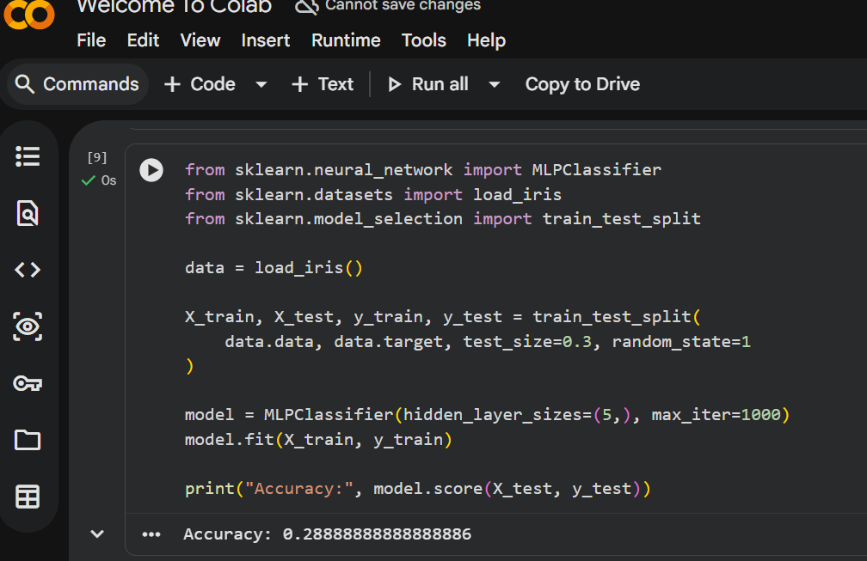

RESULT
Thus the Artificial Neural Network using Backpropagation was successfully implemented.

EXP NO:5
Write a program for Implementation of K-Nearest Neighbours (K-NN) in Python
AIM
To implement the K-Nearest Neighbors algorithm.
ALGORITHM
- Select the value of K.
- Calculate distance between test and training samples.
- Choose K nearest neighbors.
- Find majority class.
- Assign the class to test data.
CODE
from sklearn.neighbors import KNeighborsClassifier
from sklearn.datasets import load_iris
from sklearn.model_selection import train_test_split

data = load_iris()

X_train,X_test,y_train,y_test = train_test_split(data.data,data.target,test_size=0.3)

model = KNeighborsClassifier(n_neighbors=3)
model.fit(X_train,y_train)

print("Accuracy:",model.score(X_test,y_test))
OUTPUT:
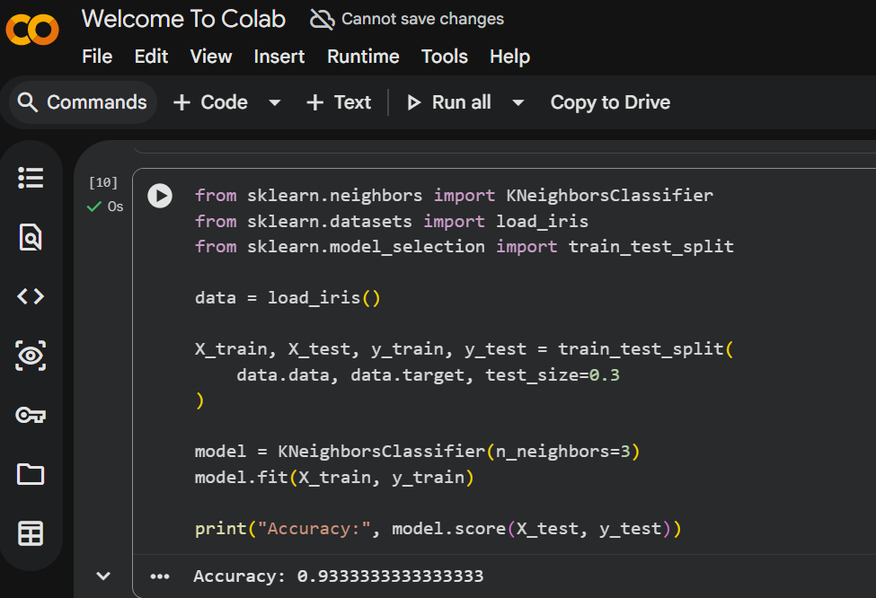
RESULT
Thus the K-Nearest Neighbours algorithm was successfully implemented.

EXP NO:6
Write a program to implement Naïve Bayes algorithm in python and to display the results using confusion matrix and accuracy.
AIM
To implement the Naive Bayes classifier and evaluate using confusion matrix and accuracy.
ALGORITHM
- Read training dataset.
- Calculate prior probability of each class.
- Calculate likelihood probabilities.
- Apply Bayes theorem.
- Predict class with highest probability.
CODE
from sklearn.naive_bayes import GaussianNB
from sklearn.datasets import load_iris
from sklearn.model_selection import train_test_split
from sklearn.metrics import confusion_matrix,accuracy_score

data = load_iris()

X_train,X_test,y_train,y_test = train_test_split(data.data,data.target,test_size=0.3)

model = GaussianNB()
model.fit(X_train,y_train)

pred = model.predict(X_test)

print("Confusion Matrix:\n",confusion_matrix(y_test,pred))
print("Accuracy:",accuracy_score(y_test,pred))
OUTPUT:
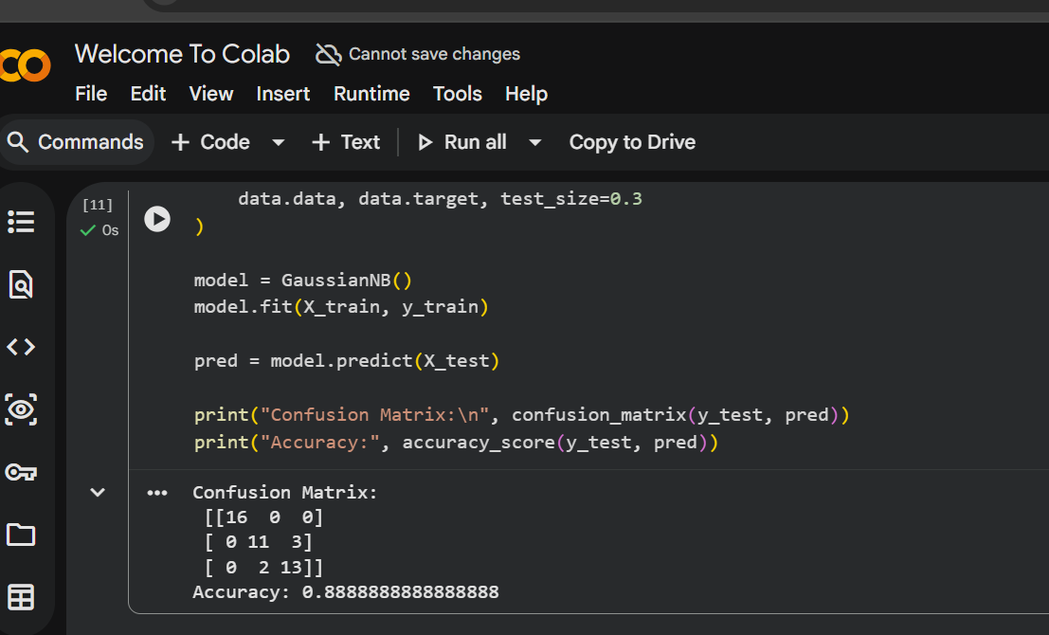
RESULT
Thus the Naïve Bayes algorithm was successfully implemented and evaluated.

EXP NO:7
Write a program to implement Logistic Regression (LR) algorithm in python
AIM
To implement Logistic Regression.
ALGORITHM
- Initialize model parameters.
- Apply sigmoid function to compute probability.
- Calculate error.
- Update weights using gradient descent.
- Repeat until convergence.
CODE
from sklearn.linear_model import LogisticRegression
from sklearn.datasets import load_iris
from sklearn.model_selection import train_test_split

data = load_iris()

X_train,X_test,y_train,y_test = train_test_split(data.data,data.target,test_size=0.3)

model = LogisticRegression(max_iter=200)
model.fit(X_train,y_train)

print("Accuracy:",model.score(X_test,y_test))
OUTPUT:
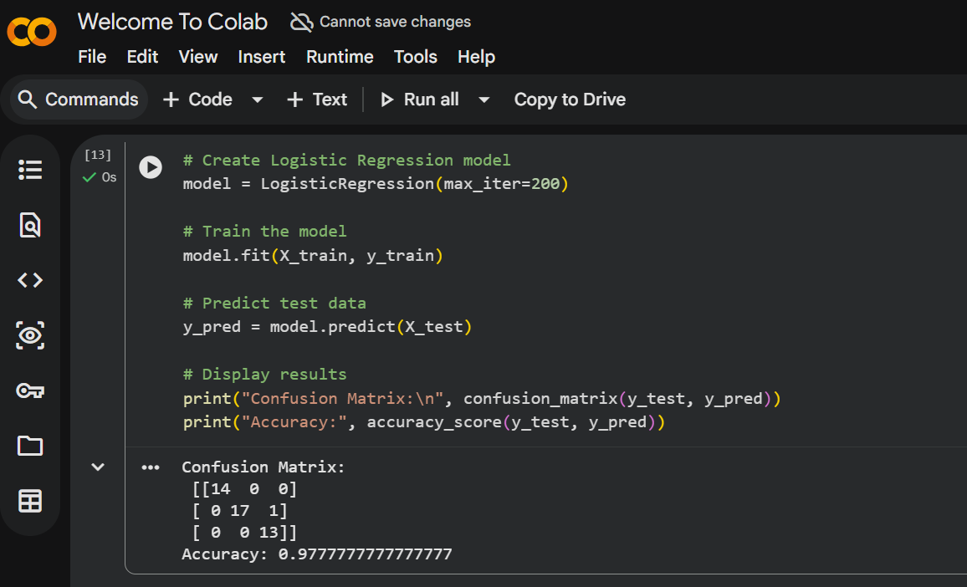
RESULT
Thus the Logistic Regression algorithm was successfully implemented.

EXP NO:8
Write a program to implement Linear Regression (LR) algorithm in python
AIM
To implement Linear Regression.
ALGORITHM
- Read dataset.
- Define input and output variables.
- Fit the regression model.
- Compute regression line.
- Predict output.
CODE
# Linear Regression in Python

from sklearn.linear_model import LinearRegression
import numpy as np

# Sample dataset
X = np.array([[1], [2], [3], [4], [5]]) # Independent variable
y = np.array([2, 4, 6, 8, 10]) # Dependent variable

# Create Linear Regression model
model = LinearRegression()

# Train the model
model.fit(X, y)

# Predict value
prediction = model.predict([[6]])

# Display results
print("Prediction for input 6:", prediction)
OUTPUT:
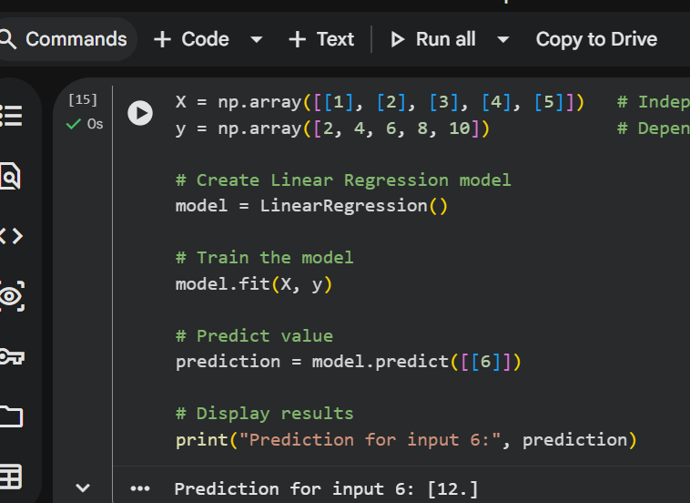

RESULT
Thus the Linear Regression model was successfully implemented.

EXP NO:9
Compare Linear and Polynomial Regression using Python

AIM
To compare Linear Regression and Polynomial Regression.
ALGORITHM
- Load dataset.
- Fit linear regression model.
- Convert features into polynomial form.
- Fit polynomial regression model.
- Compare results.
CODE
import numpy as np
from sklearn.linear_model import LinearRegression
from sklearn.preprocessing import PolynomialFeatures

X = np.array([1,2,3,4,5]).reshape(-1,1)
y = np.array([1,4,9,16,25])

lin = LinearRegression()
lin.fit(X,y)

poly = PolynomialFeatures(degree=2)
X_poly = poly.fit_transform(X)

lin2 = LinearRegression()
lin2.fit(X_poly,y)

print("Linear:",lin.predict([[6]]))
print("Polynomial:",lin2.predict(poly.transform([[6]])))
OUTPUT:
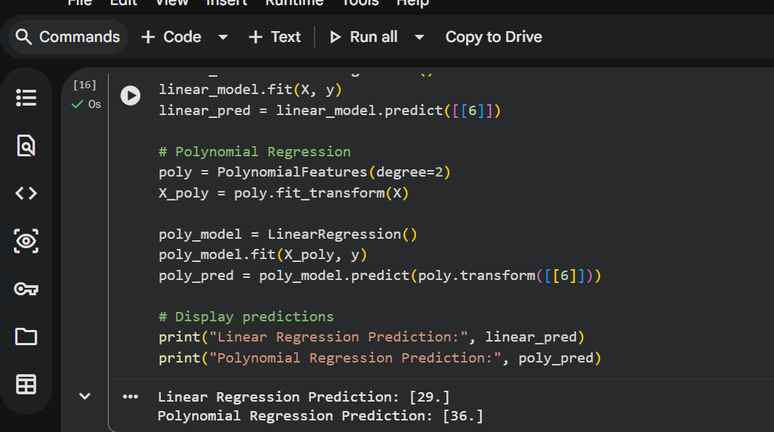
RESULT
Thus the comparison between linear and polynomial regression was successfully performed.

EXP NO:10
Write a Python Program to Implement Expectation & Maximization Algorithm
AIM
To implement the Expectation-Maximization algorithm.
ALGORITHM
- Initialize parameters randomly.
- Perform Expectation step to estimate probabilities.
- Perform Maximization step to update parameters.
- Repeat until convergence.
- Assign clusters.
CODE
from sklearn.mixture import GaussianMixture
import numpy as np

X = np.array([[1],[2],[3],[10],[11],[12]])

model = GaussianMixture(n_components=2)
model.fit(X)

labels = model.predict(X)

print("Cluster Labels:",labels)
OUTPUT:
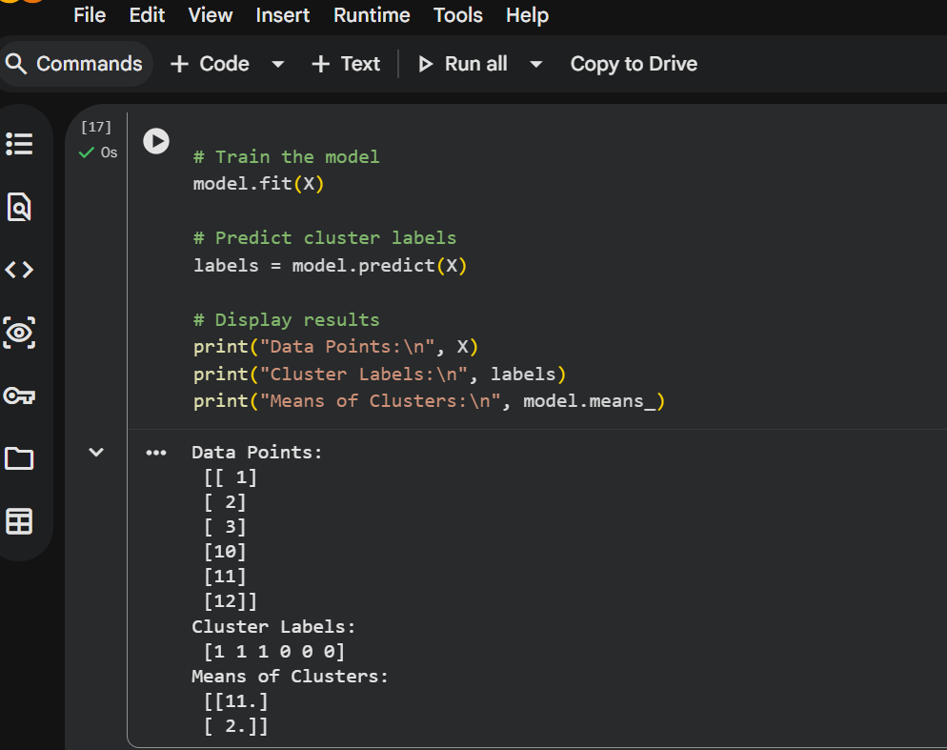

RESULT
Thus the Expectation Maximization algorithm was successfully implemented for clustering.
Below is the same lab format including ALGORITHM for each experiment in Machine Learning using Python.

EXP NO: 11
Write a program for the task of Credit Score Classification.
AIM
To build a model for credit score classification.
ALGORITHM
- Import required libraries.
- Load or create the dataset.
- Split the dataset into training and testing sets.
- Train the classifier model.
- Predict the output for test data.
- Evaluate the model accuracy.
PROGRAM CODE
# Credit Score Classification

import pandas as pd
from sklearn.model_selection import train_test_split
from sklearn.tree import DecisionTreeClassifier
from sklearn.metrics import accuracy_score

# Dataset
data = {
'Income':[25000,40000,50000,60000,20000,70000,80000,30000,90000,100000],
'Age':[25,35,45,32,23,40,50,28,55,60],
'Loan':[5000,10000,15000,20000,3000,25000,30000,7000,35000,40000],
'Score':[0,1,1,2,0,2,2,1,2,2] # 0=Low,1=Medium,2=High
}

df = pd.DataFrame(data)

X = df[['Income','Age','Loan']]
y = df['Score']

X_train,X_test,y_train,y_test = train_test_split(X,y,test_size=0.2)

model = DecisionTreeClassifier()
model.fit(X_train,y_train)

pred = model.predict(X_test)

print("Accuracy:",accuracy_score(y_test,pred))

# Predict new customer
print("Predicted Credit Score:", model.predict([[45000,30,12000]]))OUTPUT:
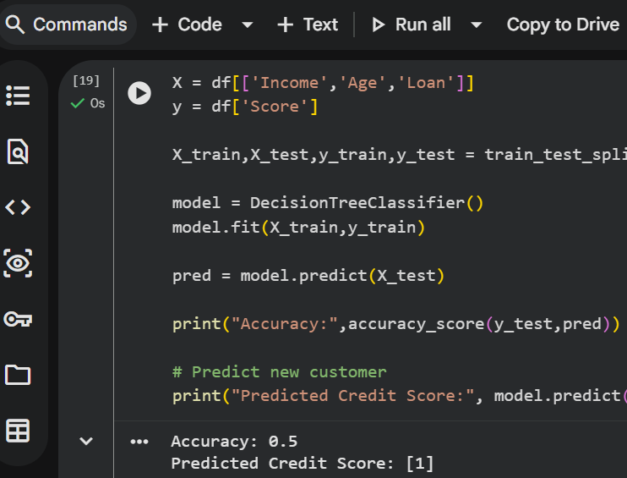
RESULT
Thus the credit score classification model was successfully implemented.

EXP NO: 12
Implement Iris Flower Classification using KNN.
AIM:
To classify iris flowers using K-Nearest Neighbors algorithm.
ALGORITHM:
- Import necessary libraries.
- Load the iris dataset.
- Split dataset into training and testing sets.
- Create KNN classifier model.
- Train the model using training data.
- Predict the test dataset and evaluate accuracy.
PROGRAM CODE:
# Import libraries
from sklearn.datasets import load_iris
from sklearn.model_selection import train_test_split
from sklearn.neighbors import KNeighborsClassifier
from sklearn.metrics import accuracy_score

# Load dataset
iris = load_iris()
X = iris.data
y = iris.target

# Split dataset
X_train, X_test, y_train, y_test = train_test_split(X, y, test_size=0.2)

# Create KNN model
model = KNeighborsClassifier(n_neighbors=3)

# Train model
model.fit(X_train, y_train)

# Predict
pred = model.predict(X_test)

# Accuracy
print("Accuracy:", accuracy_score(y_test, pred))

# Predict new flower
print("Predicted Class:", model.predict([[5.1,3.5,1.4,0.2]]))
OUTPUT:
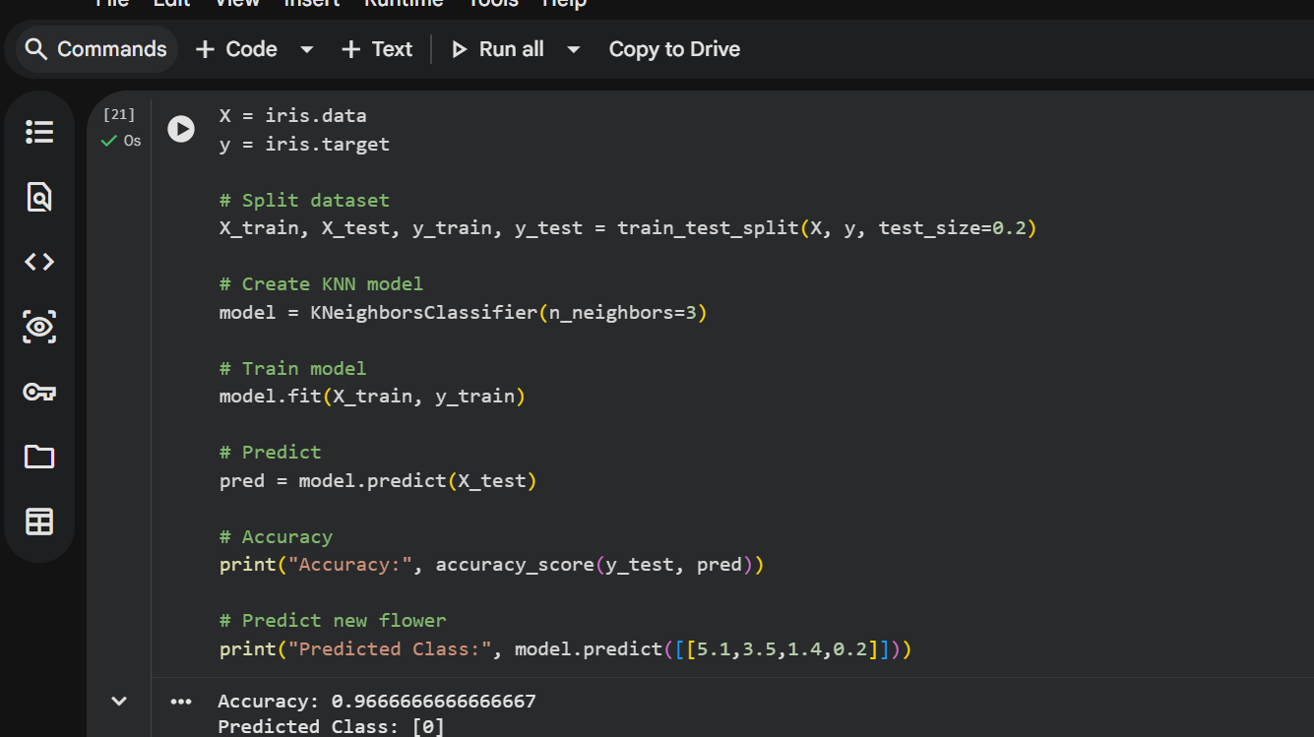

RESULT
Thus iris flower classification using KNN was successfully implemented.

EXP NO: 13
Implement the Car Price Prediction Model using Python.
AIM
To predict car price using regression.
ALGORITHM
- Import necessary libraries.
- Prepare dataset with input features and target values.
- Create regression model.
- Train the model using training data.
- Predict the price using test input.
- Display the predicted output.
PROGRAM CODE
# Car Price Prediction using Linear Regression

import pandas as pd
from sklearn.model_selection import train_test_split
from sklearn.linear_model import LinearRegression
from sklearn.metrics import mean_absolute_error

# Sample dataset
data = {
'Year':[2015,2016,2017,2018,2019,2020,2021,2014,2013,2022],
'Mileage':[50000,40000,30000,20000,15000,10000,8000,60000,70000,5000],
'Price':[500000,550000,600000,650000,700000,750000,800000,450000,400000,850000]
}

df = pd.DataFrame(data)

# Features and Target
X = df[['Year','Mileage']]
y = df['Price']

# Split dataset
X_train, X_test, y_train, y_test = train_test_split(X,y,test_size=0.2,random_state=42)

# Train model
model = LinearRegression()
model.fit(X_train,y_train)

# Prediction
pred = model.predict(X_test)

# Error
print("Mean Absolute Error:", mean_absolute_error(y_test,pred))

# Predict price of a new car
print("Predicted Price:", model.predict([[2020,12000]]))
OUTPUT:
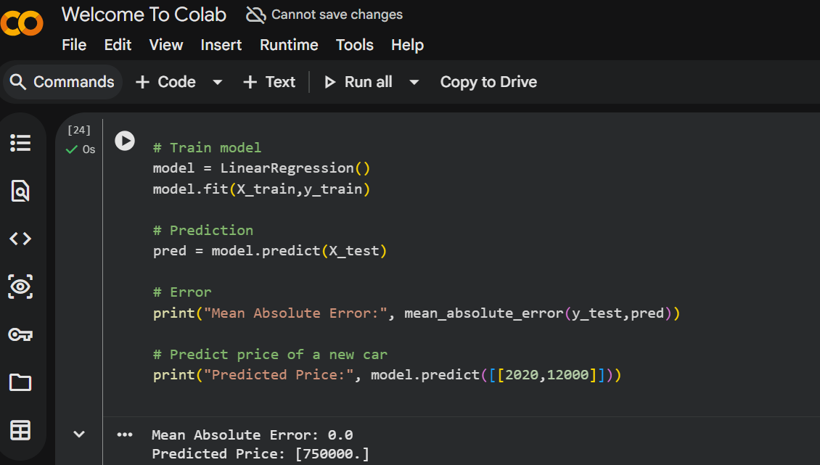

RESULT
Thus the car price prediction model was successfully implemented.

EXP NO: 14
Implement House Price Prediction using appropriate machine learning algorithm.
AIM
To predict house prices using regression.
ALGORITHM
- Import libraries.
- Create dataset with house features and prices.
- Train regression model.
- Predict house price using trained model.
- Display predicted result.
PROGRAM CODE
# House Price Prediction using Linear Regression

import pandas as pd
from sklearn.model_selection import train_test_split
from sklearn.linear_model import LinearRegression
from sklearn.metrics import mean_squared_error

# Sample dataset
data = {
'Area':[1000,1200,1500,1800,2000,2200,2500,2700,3000,3200],
'Bedrooms':[2,2,3,3,3,4,4,4,5,5],
'Age':[10,8,6,5,4,3,2,2,1,1],
'Price':[200000,220000,250000,280000,300000,320000,350000,370000,400000,420000]
}

df = pd.DataFrame(data)

# Features and Target
X = df[['Area','Bedrooms','Age']]
y = df['Price']

# Split data
X_train, X_test, y_train, y_test = train_test_split(X,y,test_size=0.2,random_state=42)

# Train model
model = LinearRegression()
model.fit(X_train,y_train)

# Prediction
pred = model.predict(X_test)

# Error
print("Mean Squared Error:", mean_squared_error(y_test,pred))

# Predict new house price
print("Predicted House Price:", model.predict([[2100,3,4]]))
OUTPUT:
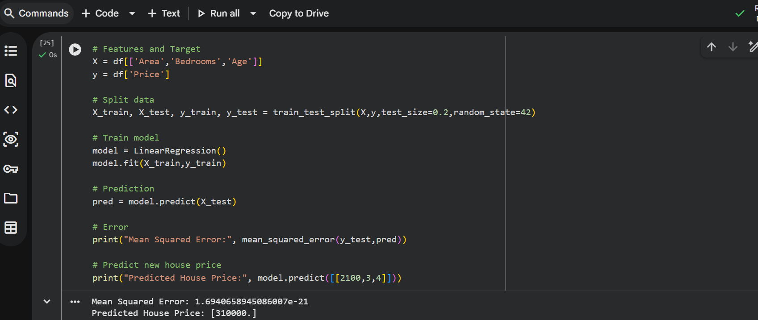
RESULT
Thus the house price prediction model was successfully implemented.

EXP NO: 15
Implement Iris Flower Classification using Naive Bayes classifier.
AIM
To classify iris flowers using Naive Bayes classifier.
ALGORITHM
- Import libraries.
- Load iris dataset.
- Split dataset into training and testing sets.
- Train Naive Bayes model.
- Predict output for test dataset.
- Calculate accuracy.
PROGRAM CODE
# Iris Flower Classification using Naive Bayes

from sklearn.datasets import load_iris
from sklearn.model_selection import train_test_split
from sklearn.naive_bayes import GaussianNB
from sklearn.metrics import accuracy_score

# Load dataset
iris = load_iris()
X = iris.data
y = iris.target

# Split data
X_train, X_test, y_train, y_test = train_test_split(X, y, test_size=0.2, random_state=42)

# Create model
model = GaussianNB()
model.fit(X_train, y_train)

# Prediction
y_pred = model.predict(X_test)

# Accuracy
print("Accuracy:", accuracy_score(y_test, y_pred))

# Predict new flower
print("Predicted Class:", iris.target_names[model.predict([[5.1,3.5,1.4,0.2]])][0])
OUTPUT:
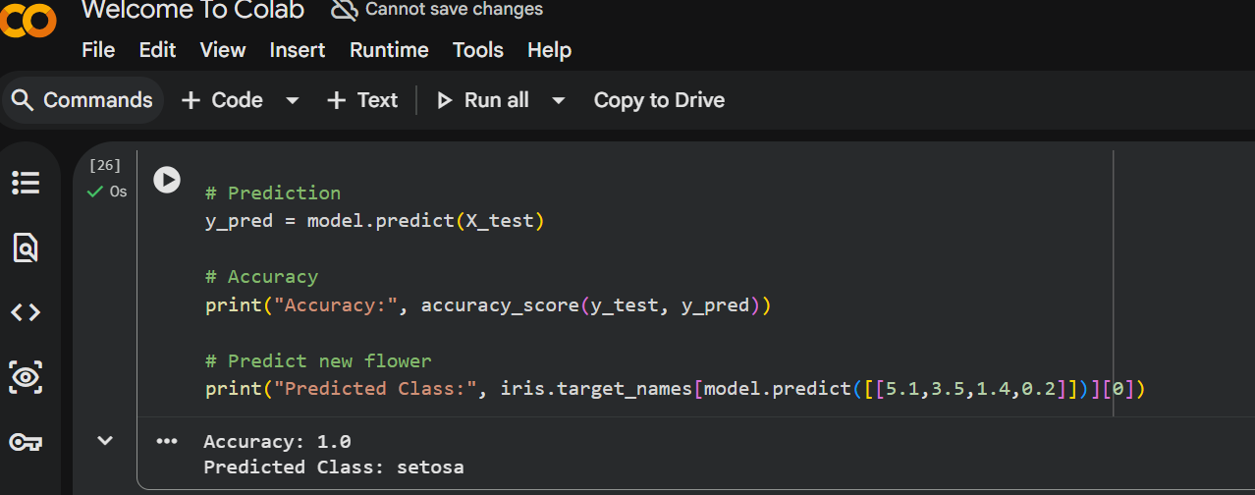
RESULT
Thus iris flower classification using Naive Bayes was successfully implemented.

EXP NO: 16
Compare different types of classification algorithms.
AIM
To compare the performance of multiple classification models.
ALGORITHM
- Import required libraries.
- Load the dataset.
- Split the dataset into training and testing data.
- Train different classification models.
- Predict outputs using each model.
- Compare their accuracies.
PROGRAM CODE
# Compare Classification Algorithms

from sklearn.datasets import load_iris
from sklearn.model_selection import train_test_split
from sklearn.metrics import accuracy_score
from sklearn.neighbors import KNeighborsClassifier
from sklearn.tree import DecisionTreeClassifier
from sklearn.naive_bayes import GaussianNB

# Load dataset
iris = load_iris()
X = iris.data
y = iris.target

# Split dataset
X_train,X_test,y_train,y_test = train_test_split(X,y,test_size=0.2,random_state=42)

# Models
models = {
"KNN": KNeighborsClassifier(),
"Decision Tree": DecisionTreeClassifier(),
"Naive Bayes": GaussianNB()
}

# Train and evaluate
for name, model in models.items():
model.fit(X_train,y_train)
pred = model.predict(X_test)
print(name,"Accuracy:",accuracy_score(y_test,pred))
OUTPUT:
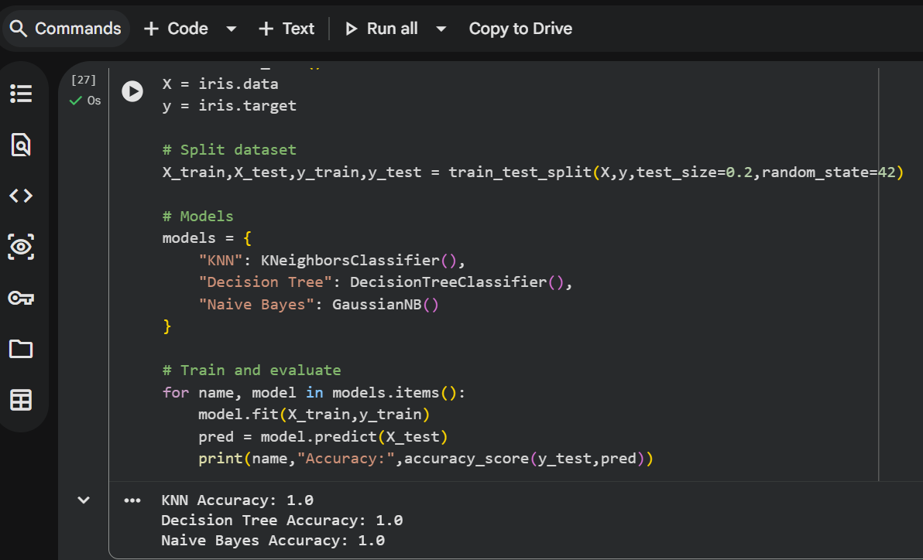
RESULT
Thus different classification algorithms were compared successfully.

EXP NO: 17
Implement Mobile Price Prediction using machine learning.
AIM
To predict mobile price using regression.
ALGORITHM
- Import required libraries.
- Prepare dataset with mobile features and price.
- Train regression model.
- Predict mobile price.
- Display result.
PROGRAM CODE
# Mobile Price Prediction using Decision Tree

import pandas as pd
from sklearn.model_selection import train_test_split
from sklearn.tree import DecisionTreeClassifier
from sklearn.metrics import accuracy_score

# Sample dataset
data = {
'RAM':[2,3,4,6,8,12,16,3,4,6],
'Storage':[16,32,64,128,128,256,512,32,64,128],
'Battery':[3000,3200,3500,4000,4500,5000,6000,3300,3600,4200],
'Price_Range':[0,0,1,1,2,2,3,0,1,2] # 0=Low,1=Medium,2=High,3=Premium
}

df = pd.DataFrame(data)

# Features and target
X = df[['RAM','Storage','Battery']]
y = df['Price_Range']

# Split dataset
X_train,X_test,y_train,y_test = train_test_split(X,y,test_size=0.2,random_state=42)

# Train model
model = DecisionTreeClassifier()
model.fit(X_train,y_train)

# Predict
pred = model.predict(X_test)

# Accuracy
print("Accuracy:",accuracy_score(y_test,pred))

# Predict new mobile price range
print("Predicted Price Range:",model.predict([[8,128,4500]]))
OUTPUT:
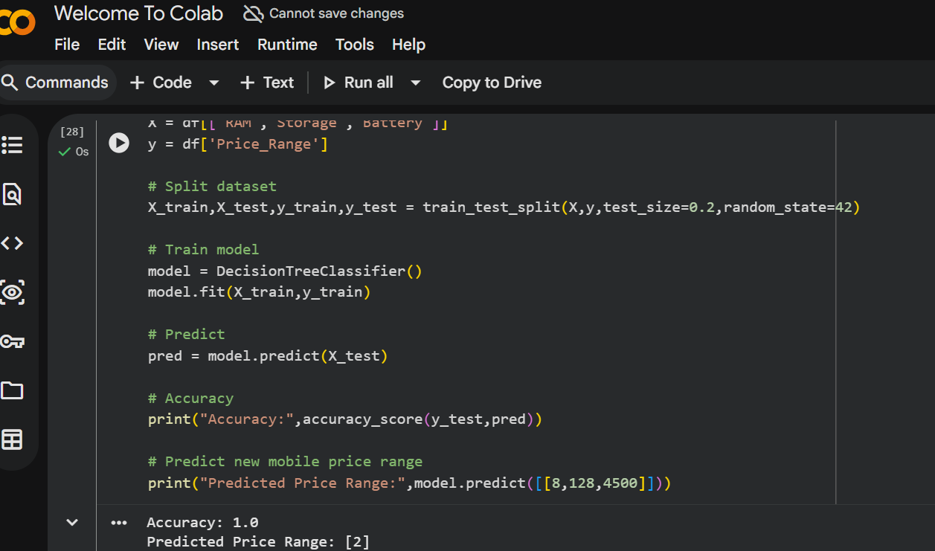
RESULT
Thus mobile price prediction was successfully implemented.
Here are the remaining experiments (18–20) in the same lab format: Question, Aim, Algorithm, Program Code, Result for Machine Learning using Python.

EXP NO: 18
Implement Perceptron based IRIS classification.
AIM
To classify the iris dataset using the Perceptron algorithm.
ALGORITHM
- Import required libraries.
- Load the iris dataset.
- Split the dataset into training and testing data.
- Create the perceptron model.
- Train the model using training data.
- Predict the class labels for test data.
- Evaluate the model accuracy.
PROGRAM CODE
# Perceptron based IRIS Classification

from sklearn.datasets import load_iris
from sklearn.model_selection import train_test_split
from sklearn.linear_model import Perceptron
from sklearn.metrics import accuracy_score

# Load dataset
iris = load_iris()
X = iris.data
y = iris.target

# Split dataset
X_train, X_test, y_train, y_test = train_test_split(X, y, test_size=0.2, random_state=42)

# Train Perceptron model
model = Perceptron()
model.fit(X_train, y_train)

# Prediction
pred = model.predict(X_test)

# Accuracy
print("Accuracy:", accuracy_score(y_test, pred))

# Predict new flower
print("Predicted Class:", iris.target_names[model.predict([[5.1,3.5,1.4,0.2]])][0])
OUTPUT:
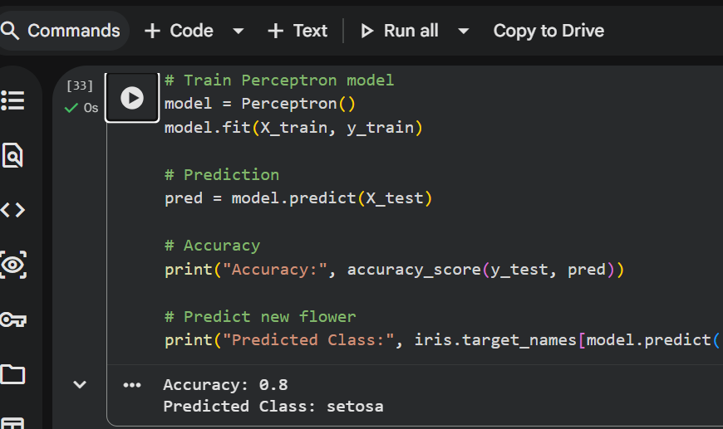

RESULT
Thus the iris dataset classification using the Perceptron algorithm was successfully implemented.

EXP NO: 19
Implementation of Naive Bayes classification for Bank Loan prediction.
AIM
To predict bank loan approval using the Naive Bayes classifier.
ALGORITHM
- Import required libraries.
- Create a dataset with customer income and loan status.
- Split the dataset into training and testing sets.
- Train the Naive Bayes model.
- Predict loan approval for test data.
- Display prediction results.
PROGRAM CODE
# Bank Loan Prediction using Naive Bayes

import pandas as pd
from sklearn.model_selection import train_test_split
from sklearn.naive_bayes import GaussianNB
from sklearn.metrics import accuracy_score

# Sample dataset
data = {
'Income':[25000,40000,50000,60000,20000,70000,80000,30000,90000,100000],
'Credit_Score':[600,650,700,750,580,720,780,640,800,820],
'Loan':[5000,10000,15000,20000,3000,25000,30000,7000,35000,40000],
'Approved':[0,0,1,1,0,1,1,0,1,1] # 0=No,1=Yes
}

df = pd.DataFrame(data)

# Features and target
X = df[['Income','Credit_Score','Loan']]
y = df['Approved']

# Split dataset
X_train,X_test,y_train,y_test = train_test_split(X,y,test_size=0.2,random_state=42)

# Train model
model = GaussianNB()
model.fit(X_train,y_train)

# Prediction
pred = model.predict(X_test)

# Accuracy
print("Accuracy:", accuracy_score(y_test,pred))

# Predict new customer loan approval
print("Loan Approval Prediction:", model.predict([[45000,680,12000]]))OUTPUT:
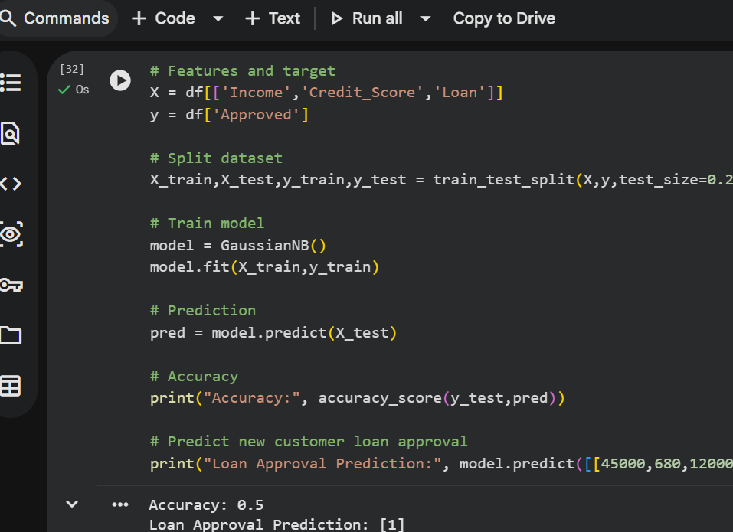
RESULT
Thus bank loan prediction using Naive Bayes classification was successfully implemented.

EXP NO: 20
Implement Future Sales Prediction using a suitable machine learning algorithm.
AIM
To predict future sales using the Linear Regression algorithm.
ALGORITHM
- Import required libraries.
- Create dataset containing past sales data.
- Split dataset into input and output variables.
- Train the regression model.
- Predict future sales values.
- Display predicted sales.
PROGRAM CODE
from sklearn.linear_model import LinearRegression
import numpy as np

# Past sales data
X = np.array([[1],[2],[3],[4],[5]])
y = np.array([100,120,140,160,180])

# Create model
model = LinearRegression()

# Train model
model.fit(X, y)

# Predict future sales
future_sales = model.predict([[6]])

print("Predicted Future Sales:", future_sales)
OUTPUT:
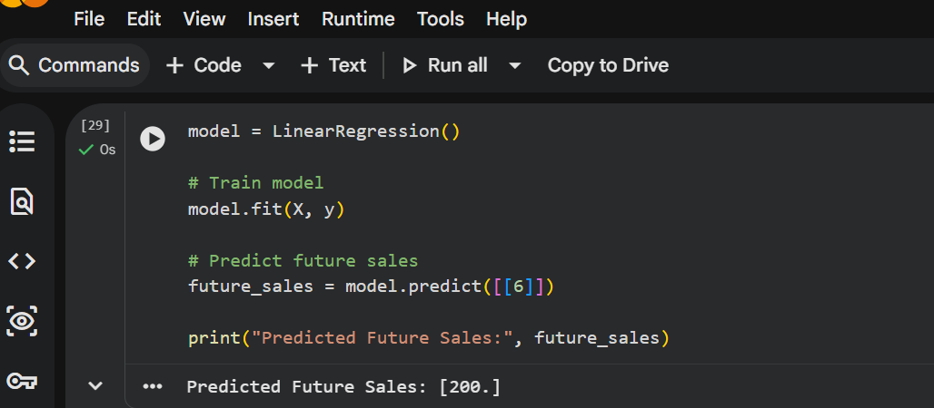
RESULT
Thus future sales prediction using machine learning was successfully implemented.

